**Subject:**

TC4002 - Analysis, Design and Construction of Software Systems

**Professor:**

Gerardo Padilla Zarate

**L4.2 - Code Coverage and Coding Standard**

**Student:**

Juan Francisco Corral Stenner A00354823

For this assignment, I had to go back and modified some of my programs in order to get the most coverage possible. Lab3_17.py and lab3_19.py asked for the unit testing of a built-in function, math.factorial() and filecmp.com(), respectively, I had to slightly modified them in order to applied the proper unit test to them.

1) For all previous exercises, measure the coverage for your testing. Provide Screenshots for the measurements. Try to achieve at least 90% of Statement Coverage. Get PEP8 checking tool and modify your programs to achieve 8 issues in PEP8. Provide Screenshots as evidence.

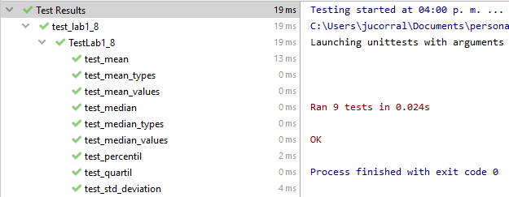

***Figure 1 - test_lab1_8.py***

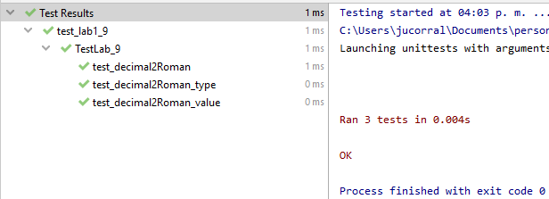

***Figure 2 - test_lab1_9.py***

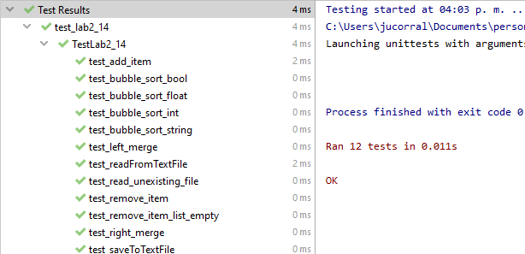

***Figure 3 - test_lab2_14.py***

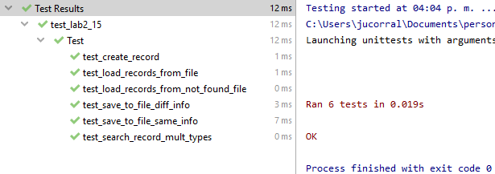

***Figure 4 - test_lab2_15.py***

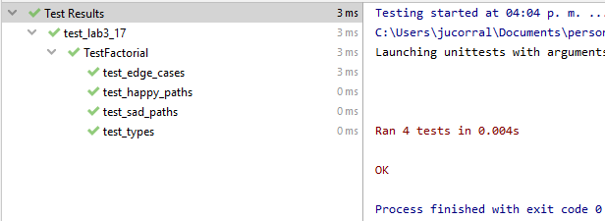

***Figure 5 - test_lab3_17.py***

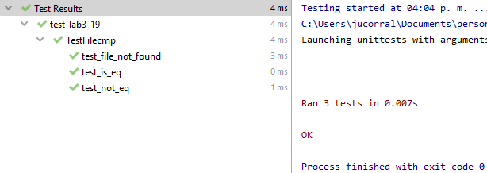

***Figure 6 - test_lab3_19.py***

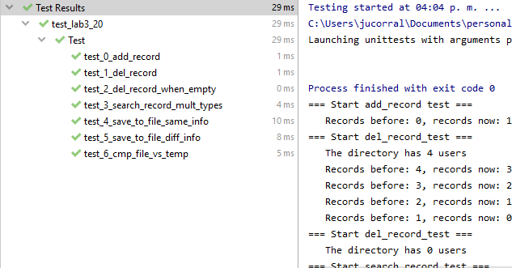

***Figure 7 - test_lab3_20.py***

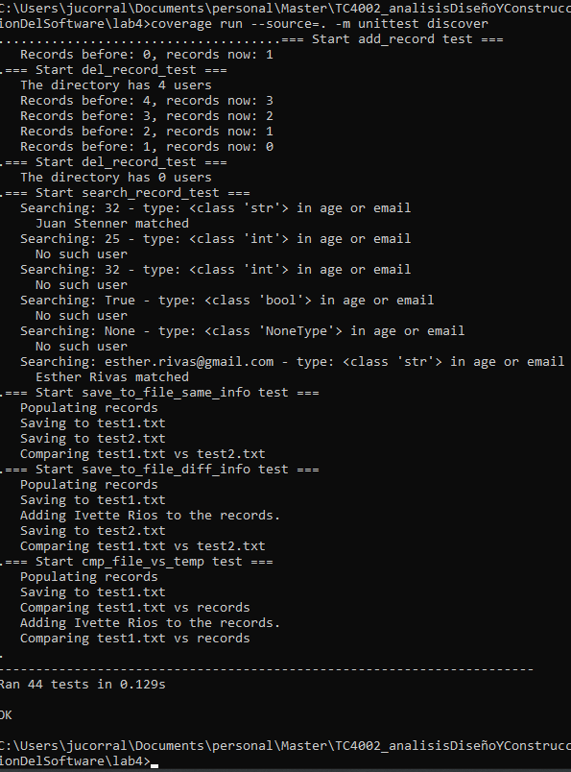

***Figure 8 - coverage run***

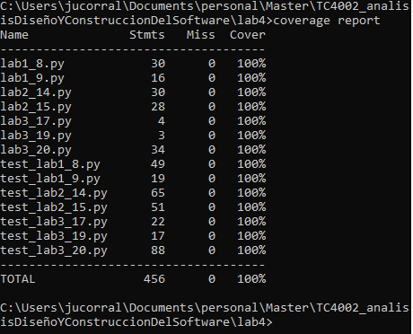

***Figure 9 – coverage report***



***Figure 10 – coverage html***